**Delete account test case**

**Goal:**

As a tester, I want to verify if the Delete Account page is working correctly.

**Background:**

Delete account page is responsible for deleting an user account.

**Steps to Reproduce**

1. Go to <https://www.find-a-house.nl/en/home> and click on the menu bar

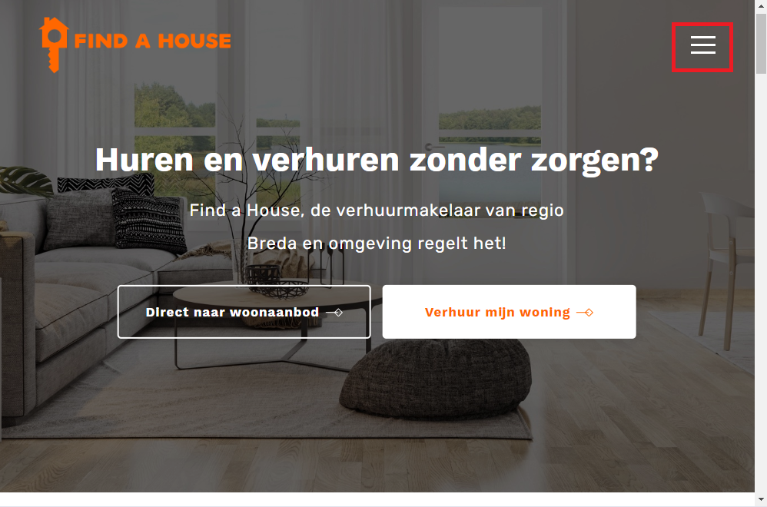

2. Click at the “Inloggen” Button to open the Login form.

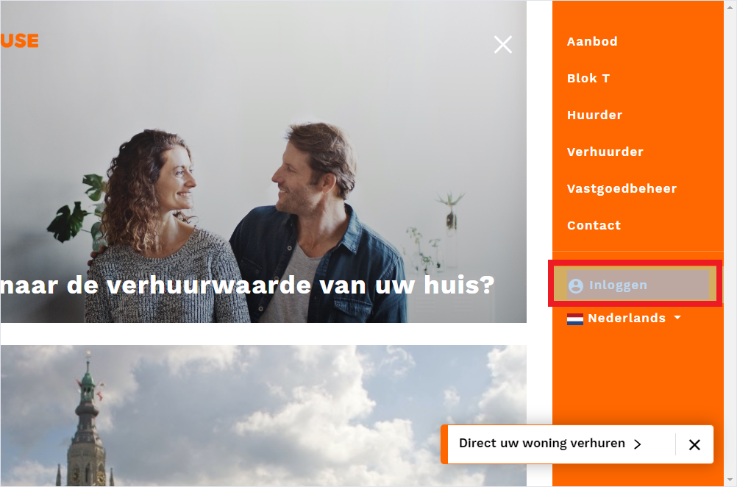

3. type an email account and password and click at the button “Inloggen”.

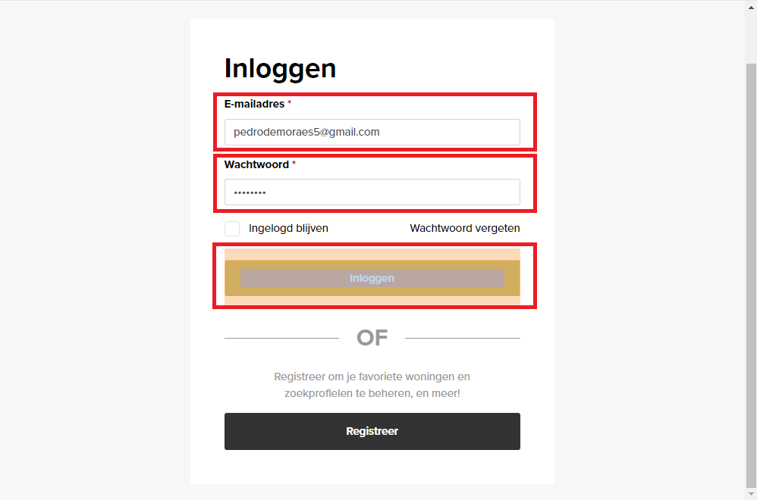

4. After the Login has been effectuated, the Dashboard page will be open.

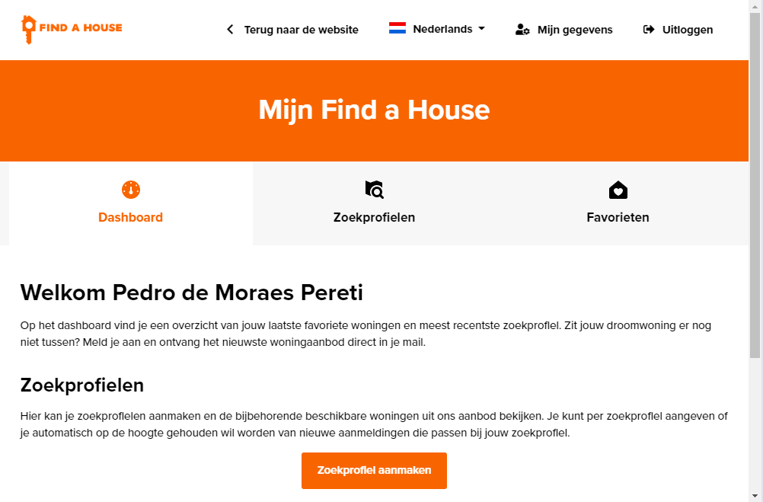

5. After the Dashboard is open, cick on “Mijn Gegevens”.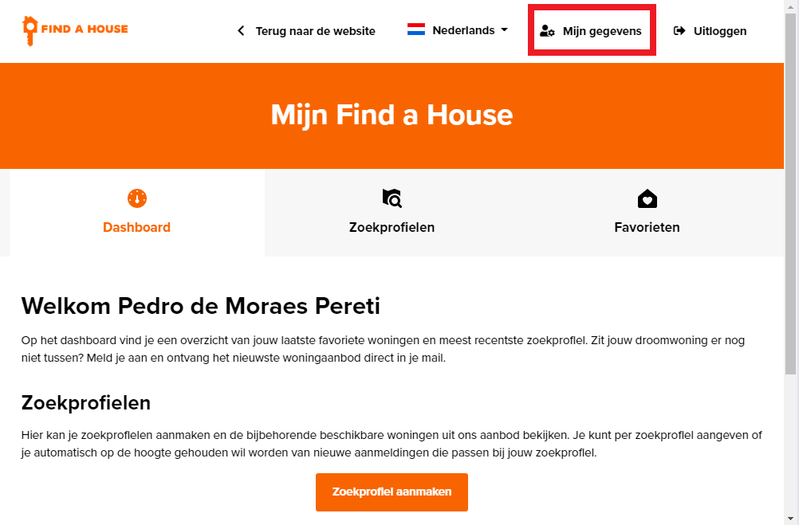

6. Click on “Account verwijderen”.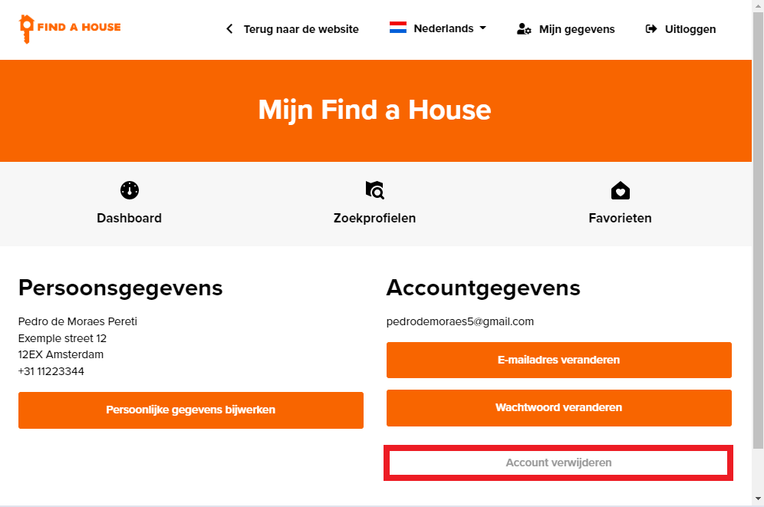

7. Click on “Annuleren.” to delete the account

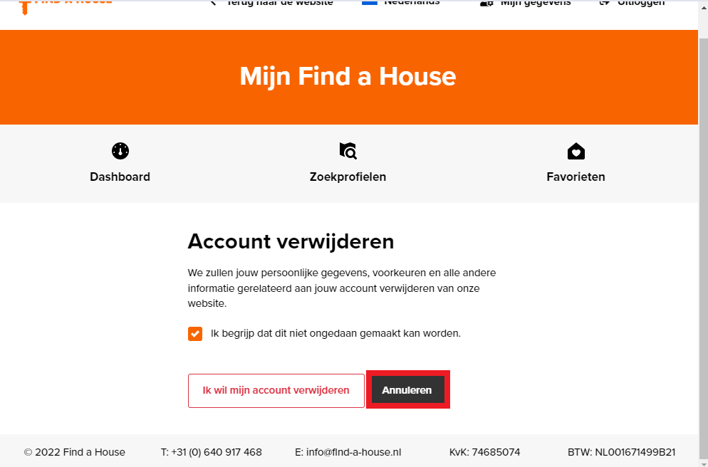

8. The page should redirect to the Personal Data Page and finish the Deleting Account procedure.

